Title of the Manuscript
Author Full Name¹*, Author Full Name²
¹ Department, Institution Name, City, Country
² Department, Institution Name, City, Country
*Corresponding Author: email@example.com
ORCID (optional): 0000-0000-0000-0000

Abstract
Provide a concise summary of the research including objective, methodology, key results, and conclusion (150–250 words).

Keywords
Keyword1, Keyword2, Keyword3, Keyword4, Keyword5

INTRODUCTION

The Introduction should clearly present the background of the study, the research problem, and the motivation for the work. Authors should:

Provide context and importance of the research area.

Clearly define the problem statement.

Identify gaps in existing research.

State research objectives and contributions.

Briefly outline the structure of the paper.

Avoid excessive literature discussion here. Focus on problem definition and contribution.

LITERATURE REVIEW
This section should critically analyze relevant existing studies.
Authors should:
- Discuss prior research related to the topic.
- Compare methodologies used in previous studies.
- Highlight limitations of earlier approaches.
- Identify research gaps.
- Justify the need for the present study.
Do not merely list previous papers. Provide comparative and analytical discussion.

  - Thematic Review of Existing Approaches
Use subsections to organize literature thematically.
Example:
    - Machine Learning Approaches
    - IoT-Based Systems
    - Optimization Techniques

  - Research Gap and Problem Identification
This subsection should clearly identify the limitations of existing studies and justify the need for the present research.
Authors should:
- Summarize key findings from previous studies discussed in Section 2.1
- Highlight methodological limitations, data constraints, or performance gaps
- Identify unresolved research challenges
- Clearly state what is missing in current literature
- Explain how the proposed study addresses these gaps
Avoid vague statements such as “limited research exists.” Instead, provide specific analytical comparison.

Each subsection should maintain logical flow and research clarity.

METHODOLOGY
This section must clearly describe how the research was conducted.
Include:
- Research design
- Materials and tools used
- Data collection methods
- Algorithms or mathematical models
- Experimental setup
- Statistical methods
Provide sufficient detail so that the study can be replicated.
Include equations and diagrams where necessary.

  - Proposed System Architecture
The overall framework of the proposed system is illustrated in Figure 1.
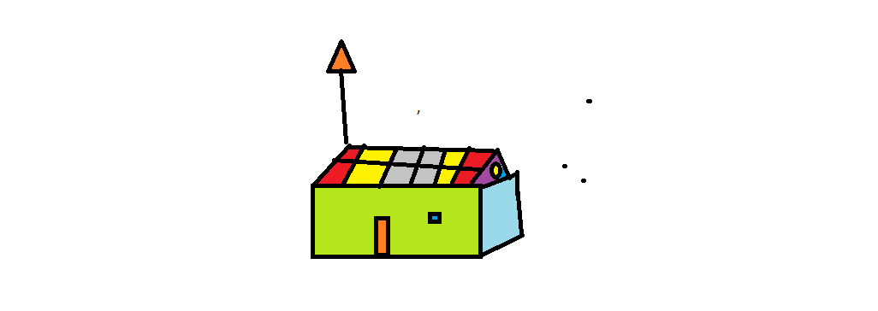
Figure 1. Architecture of the Proposed Research Framework

The proposed system consists of the following components:
- Data Acquisition Module
- Preprocessing Unit
- Feature Extraction Module
- Model Training and Testing Unit
- Performance Evaluation Module
Each module plays a significant role in ensuring accurate and reliable output.

  - Experimental Setup
The experimental configuration used in this study is summarized in Table 1. The table should be center aligned.

Table 1. Experimental Parameters Used in the Study
Sr. No. | Parameter | Value | Significance
1 | Parameter 1 | 14 | Significance 1
2 | Parameter 2 | 14 | Significance 2
3 | Parameter 3 | 14 | Significance 3

The experiments were conducted using the above configuration to evaluate model performance under controlled conditions.

  - Equations
If applicable, present equations clearly and number them sequentially:
 | $$A + B = C$$ | (1)
where:
A represents first input value.
B represents second input value.
C denotes the addition of A and B.
All variables must be defined below the equation.

RESULTS
Present findings clearly and objectively.
- Use tables and figures appropriately
- Avoid repeating table content in paragraph form
- Report statistical measures (accuracy, precision, etc.)
- Highlight significant observations
All figures must be referenced in text. For example, the performance comparison is shown in Figure 2.

DISCUSSION
Interpret and analyze the results.
Authors should:
- Explain why results occurred
- Compare findings with previous research
- Discuss practical implications
- Address limitations
- Suggest improvements
This section should demonstrate analytical depth.

CONCLUSION

Although a conclusion may review the main points of the paper, do not replicate the abstract as the conclusion. A conclusion might elaborate on the importance of the work or suggest applications and extensions. Authors are strongly encouraged not to call out multiple figures or tables in the conclusion—these should be referenced in the body of the paper. Do not introduce new data in this section.

Acknowledgements
Mention funding sources, institutional support, or technical assistance if applicable.

Conflict of Interest
The authors declare no conflict of interest. For example, the authors declare no conflict of interest. If applicable, authors must confirm that ethical approval was obtained from appropriate institutional review boards.

REFERENCES
(All references must follow IEEE style and be numbered sequentially in order of appearance. Examples are given below for reference.)
- A. Author, “Title of the paper,” Journal Name, vol. 10, no. 2, pp. 1–10, 2025.
- B. Author, Book Title. Publisher, Year.
- V. Sharma and P. Singh, “An intelligent crop yield prediction model,” International Journal of Advanced Multidisciplinary Studies and Innovation, vol. 2, no. 1, pp. 15–25, Jan. 2026.
- A. Kumar and R. Mehta, “IoT-based smart irrigation system,” in Proc. IEEE Int. Conf. Smart Systems, 2025, pp. 45–50.
- T. M. Mitchell, Machine Learning. New York, NY, USA: McGraw-Hill, 1997.
- J. Smith, “Deep learning applications,” in Advances in Artificial Intelligence, R. Brown, Ed. London, U.K.: Springer, 2023, pp. 120–135.
- World Health Organization, “Global health statistics 2024,” https://www.who.int, accessed Jan. 15, 2026.
- S. Lee, “Blockchain security analysis,” IEEE Access, vol. 9, pp. 12345–12356, 2024, doi: 10.1109/ACCESS.2024.1234567.

